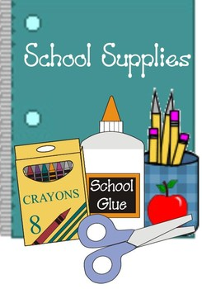
We will have all of the items below in our classroom for community use. Most students prefer to have their own “personal supply” in their learning space. We will go through some materials way faster than others, so a wish list of donations will be sent home throughout the school year. Thanks for your support!

Individual Student Supplies
__Pencils
__Erasers
__2 Highlighter
__2 Expo Markers (personal use)
__2 checking pens (any color-not blue or black)
__Pencil Pouch
__2 Glue Sticks
__4 Folders (for subjects) A daily take-home folder will be provided by the teacher.
__2 Composition Notebooks
__Ear buds/headphones (for personal technology use)

Optional for personal use:
__Colored Pencils
__Markers
__1 Jumbo Book Cover
__ Scissors (if you prefer not to use the class set)

***Please label everything with your child’s initials.
Also, your child may select desired colors/designs!***

Helpful Classroom Donations

__Kleenex
__Cleaning Wipes
__Ziplock bags-all sizes (snack, freezer, sandwich)
__Sticky notes (3x3 or 2x2…any color)
__Expo Markers
__Plastic spoons (for snack time)

